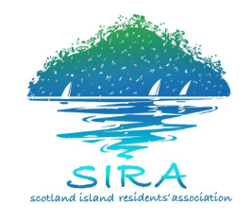
SIRA Committee Meeting

Sunday, 27th May, 2018
10:00am - 12:00pm

AGENDA
Coffee/tea station open prior to and throughout the meeting (no prescribed coffee/tea break).
Agenda Items | Time | Finish Time
Chair: Neelica Raffel – SIRA President  Acknowledgement of Country and Welcome  Apologies  Election of Time Keeper  Reception of Previous Minutes | 10.00am | 11.30am
SIRAC BUSINESS

President’s Report
(5 minutes Question time - an extension of 3 mins is available)

Treasurer’s Report
(5 minutes Question time - an extension of 3 mins is available)

Secretary’s Report
- Correspondence
(5 minutes Question time - an extension of 3 mins is available)

Working Group Reports

GENERAL BUSINESS – all members are invited to contribute  1. Pittwater Community Alliance  2. eWaste Collection on island once a year | 11.30am | 12.00pm

