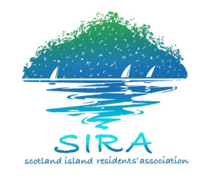
SIRA Committee Meeting

Sunday, 8th July, 2018
10:00am - 12:00pm

AGENDA
Coffee/tea station open prior to and throughout the meeting (no prescribed coffee/tea break).
Agenda Items | Time | Finish Time
Chair: Colin Haskell – SIRA Vice President  Acknowledgement of Country and Welcome  Apologies  Election of Time Keeper  Reception of Previous Minutes | 10.00am | 11.30am
SIRAC BUSINESS

President’s Report
(5 minutes Question time - an extension of 3 mins is available)

Treasurer’s Report
- SIRA Management Accounts – May
- Discussion Paper for Allowance for Reimbursement of Expenses, Office Bearers and Others
- NBC Delivery Program – SIRA Submission to Council about CPPP pricing for 2018
(5 minutes Question time - an extension of 3 mins is available)

Secretary’s Report
- Correspondence
- Membership Renewals
(5 minutes Question time - an extension of 3 mins is available)

Working Group Reports
- Community Engagement and Communications – SIRA on Facebook; website update project
- Finance and Insurance - SIRA Safe Environment Policy (anti-sexual assault and harassment)
- Roads, Drainage, Traffic and Environment - Update
- Water and Wastewater – Council Feasibility Study Working Group
- Wharves - Update
(5 minutes Question time - an extension of 3 mins is available)

GENERAL BUSINESS – all members are invited to contribute  1. Pittwater Community Alliance  2. Council Community Grants | 11.30am | 12.00pm

