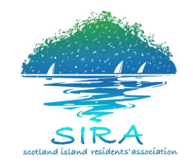
SIRA Committee Meeting – Community Hall
Sunday, 16th December, 2018 10:00am - 12:00pm

AGENDA
Coffee/tea station open prior to and throughout the meeting (no prescribed coffee/tea break).
Agenda Items | Time | Finish Time
Chair: Colin Haskell, President  Acknowledgement of Country and Welcome  Apologies  Election of Time Keeper | 10:00am | 10:15am
SIRAC BUSINESS  President’s Report  - (5 minutes Question time - an extension of 3 mins is available)  Treasurer’s Report  - SIRA Management Accounts and Treasurer’s Report – October  - Investment account with Australian Ethical Investments  - Safe Environment Policy and Officer  (5 minutes Question time - an extension of 3 mins is available)  Secretary’s Report  - Correspondence  - Membership  - Sub-committee membership  (5 minutes Question time - an extension of 3 mins is available)  Working Group Reports  - Church Point – Pasadena Liquor Licence  - Community Engagement and Communications – website; perception of SIRA’s role  - Governance – SIRA positions advertised  - Roads, Drainage, Traffic and Environment – NBC Draft Traffic Management Plan and public meeting  - Strategy and Vision  - Water and Wastewater – Wastewater Feasibility Study update; water booking automation project update  - Wharves - update | 10:15am | 11:30am
GENERAL BUSINESS – all members are invited to contribute  1. Toilets – signage about facilities on island; data collection; internal security  door  Please notify the secretary in writing by COB Friday, 14th December, 2018 of any items to be listed for general business (including motions to be brought) secretary@sira.org.au  Additional items, raised at the meeting, will only be considered for discussion if time permits | 11:30am | 12:00 noon

